# **CSE250 [Review]**

### **1. Draw the alternate representations of the following circuits** *[Note that the number of floating sources should be minimized]***.**

1. 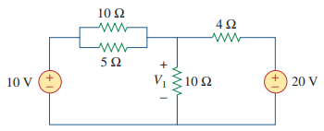
2. 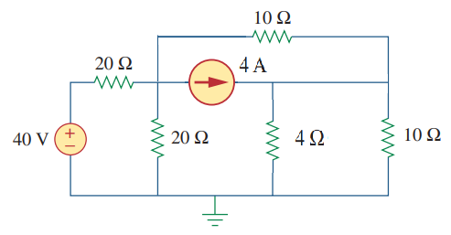

### 2. Find the loop representation of the following circuit:

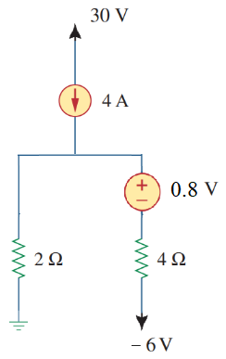

### 3. Here, vx = (10+last digit of your ID) V

### 

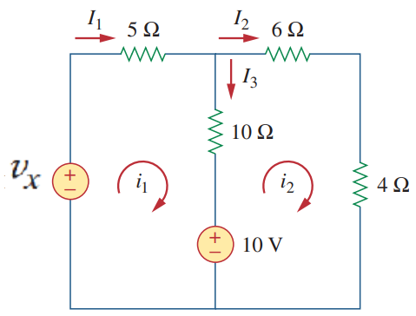

**(i) Draw the alternate circuit representation** of the circuit shown in the Figure above*[Note that the number of floating sources should be minimized]***.**

**(ii) Apply KCL and KVL** on the circuit drawn in (i) and **calculate I1, I2, and I3.**

### 4.

| **In the above circuit , and . Answer the following questions** | | |
| --- | --- | --- |
| 1. Write the node equations for the nodes indicated by and . | [CO1] | 4 |
| 1. Solve the node equations to find the values of and **.** | [CO2] | 3 |
| 1. Can circuit theorems based on linearity principle (such as superposition principle) be applied to the above circuit? Explain in short why or why not. | [CO1] | 3 |

## 

# **Op-Amp**

### Observe the following circuit.

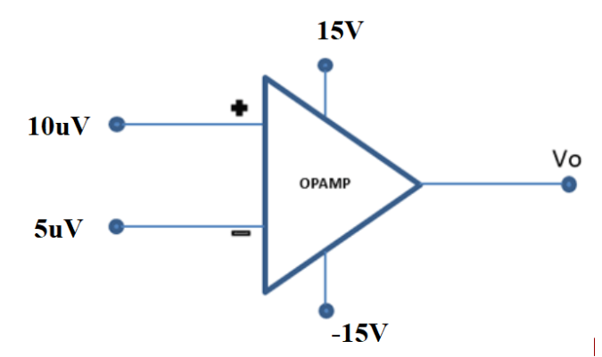

Calculate the value of Vo. Repeat the problem with V+=1 mV and V-=0.2 mV. Consider A=2105.

### Draw output Vo for the following op-amp circuit.

### 

VCC = 15V= -VEE , Vref = 1.5V, Vi is a 6V p-p triangular signal as shown below.

### 

### 

### Design a circuit using **op-amp** that has the voltage transfer characteristics as shown in the figure below. is the **output voltage** and is the **input voltage**.

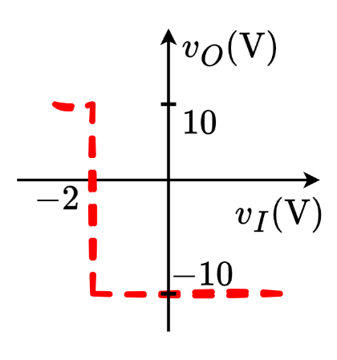

### 5.

A valve is used to release (when valve is OPEN,) or maintain (when valve is CLOSED,) water pressure in a water tank. The valve operates on **ACTIVE LOW** logic. (i.e., the valve is OPENED when given a LOW voltage of **,** but remains CLOSED when provided a HIGH voltage of **.**)

A pressure sensor is installed in the water tank that outputs a voltage linearly proportional to pressure, as shown in the table below.

| At **0.5 atm** pressure | At **1 atm** pressure | At **1.5 atm** pressure |
| --- | --- | --- |
|  |  |  |

The pressure in the water tank can be measured by the formula , where **,** (in **Pascals (Pa)** unit) is the water pressure, is the height of water in the tank (in ), is the density of water and is the acceleration due to gravity (in ).

**[1 atm = 101325 Pa]**

1. **Design** a circuit using Op-Amp comparator to automatically turn OPEN the valve if water level exceeds **10 m**.
2. **Draw** the voltage transfer characteristics (VTC) of the designed Op-Amp.

### **Solution:**

When m: Pa atm

**From the table we can interpolate and find the exact voltage at this pressure.**

For atm pressure change, the voltage changes by

For atm pressure change, the voltage changes by

So, for atm pressure change, the voltage changes by

So, voltage at 0.967 atm pressure is

**Active low logic:**

High water level High pressure **High input voltage** Valve Open

Low water level Low pressure **Low input voltage** Valve Closed

So the comparator is in inverting configuration. As shown below:

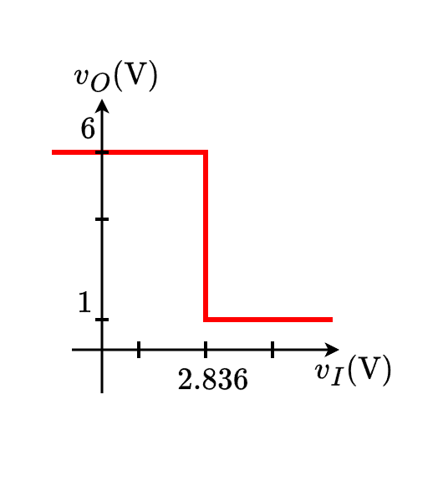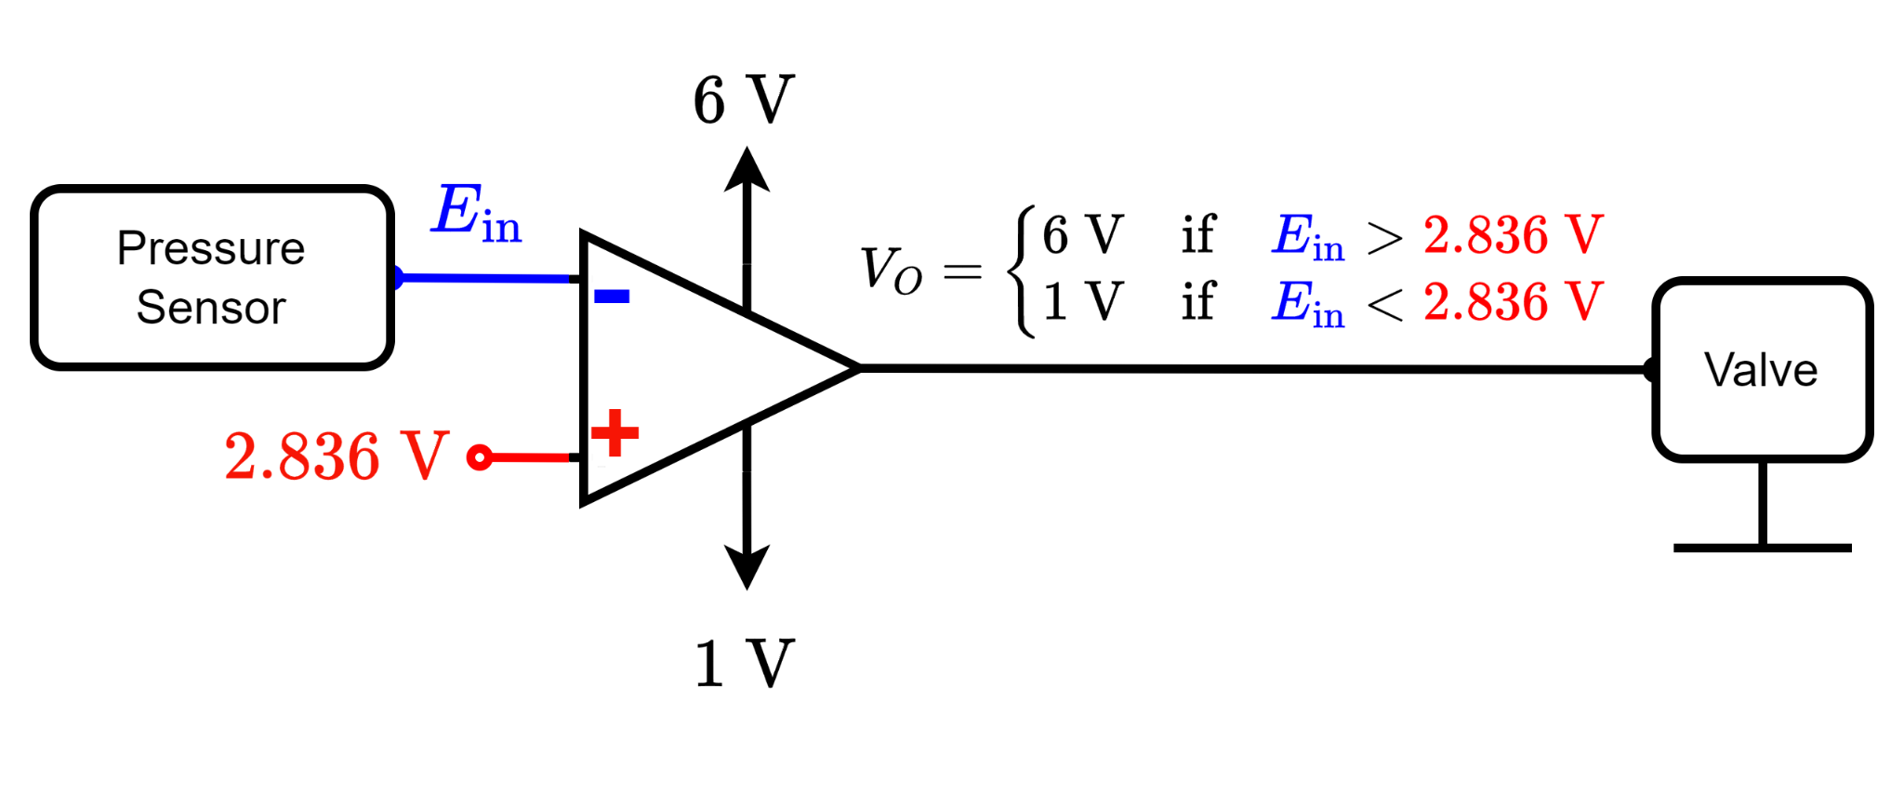

### 6.

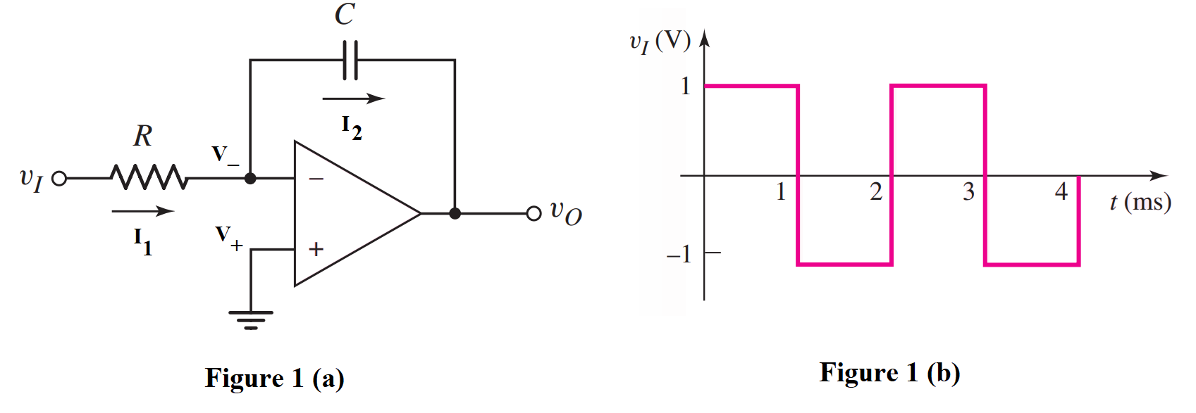

1. **Analyze** the circuit drawn in Fig. 1(a) and **determine** the voltage values at the inverting and non-inverting nodes (V- and V+). [0.5+0.5]
2. **Identify** the relation between I1 and I2. [1]
3. **Analyze** the circuit to derive the expression of output voltage vo. You have to **show** all the steps. [3]
4. Now consider the input wave v1 given in Fig. 1(b). For circuit parameters R = 10 kΩ and C = 0.1μF, **determine** the output voltage at t = 1 ms. [1]
5. **Design** a circuit using Op-Amps to implement the following expression: [4]

### 

### **Solution: (d)**

For any function of time, ***integration over time means to find the area under the time dependent curve***. The diagram below represents a generalized square wave where amplitude is and time period is . In this question **V** and **ms.** So, the area under the square input pulse until time is . For the entire half time period, this area becomes . Also, we know that the input-output relation of an inverting integrator is given by:

As the square pulse alternates between positive and negative voltages, the area under its curve subsequently increases and decreases. So, the waveform of the output voltage is shown below, where,

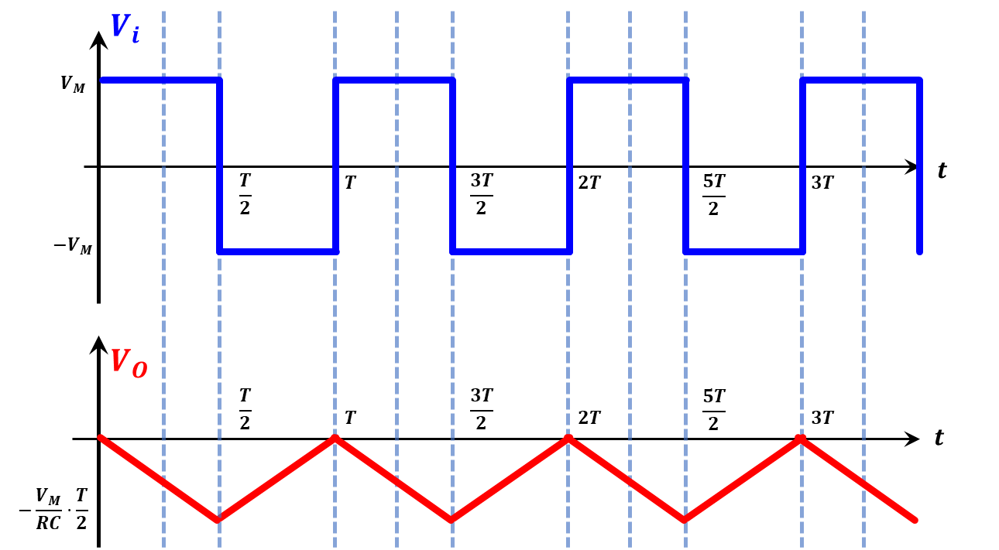

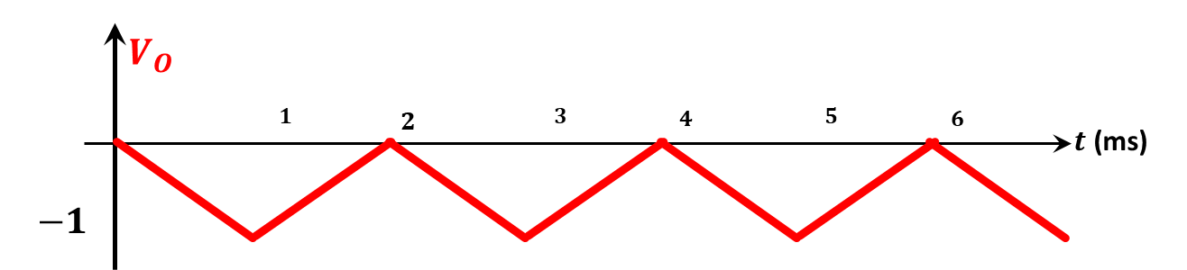

### 

### 

### 

### 

### 7.

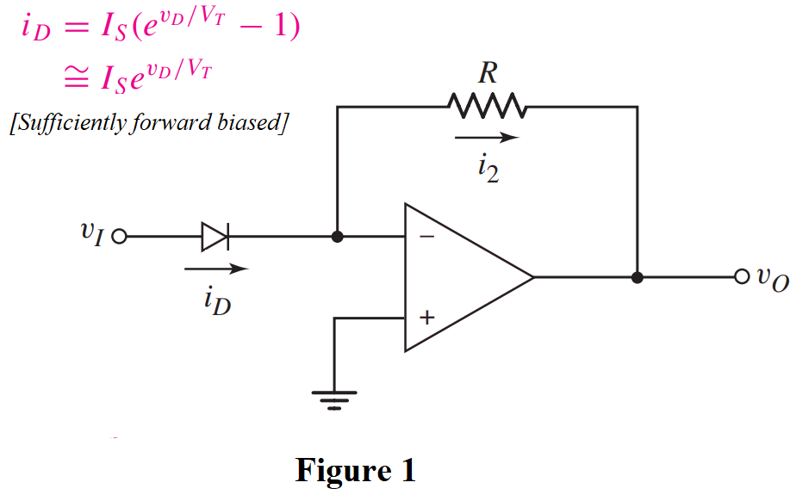

1. **Analyze** the circuit drawn in Fig. 1 and **determine** the voltage values at the inverting and non-inverting nodes (V- and V+). [0.5+0.5]
2. **Identify** and briefly explain the relation between i2 and iD. [1.5]
3. **Analyze** the circuit to derive the expression of output voltage vo. You have to **show** all the steps. [3.5]
4. **Design** a circuit using Op-Amps to implement the following expression: [4]

### **Solution:**

(b) as no current would flow through the inverting terminal (i.e., .

(c) In the given op-amp,

### 8.

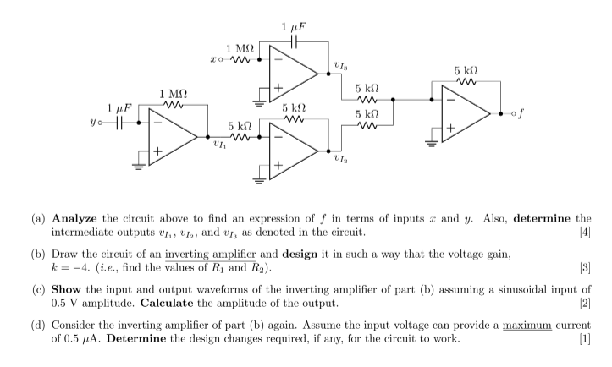

### 9.

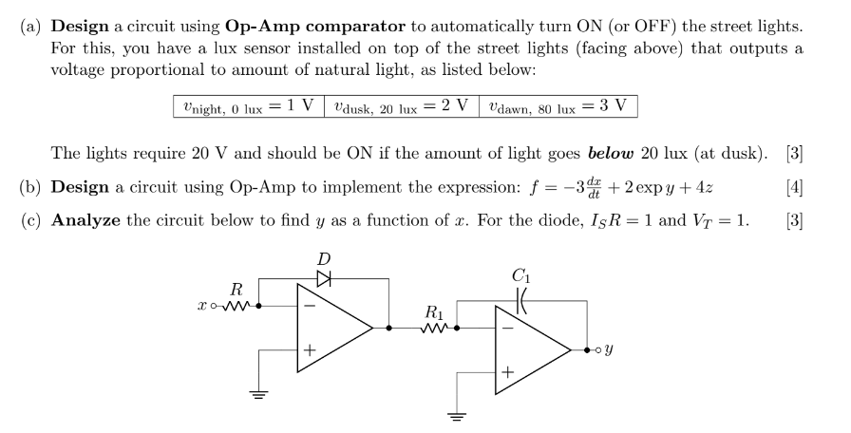

### **Solution: (a)**

Inverting configuration:

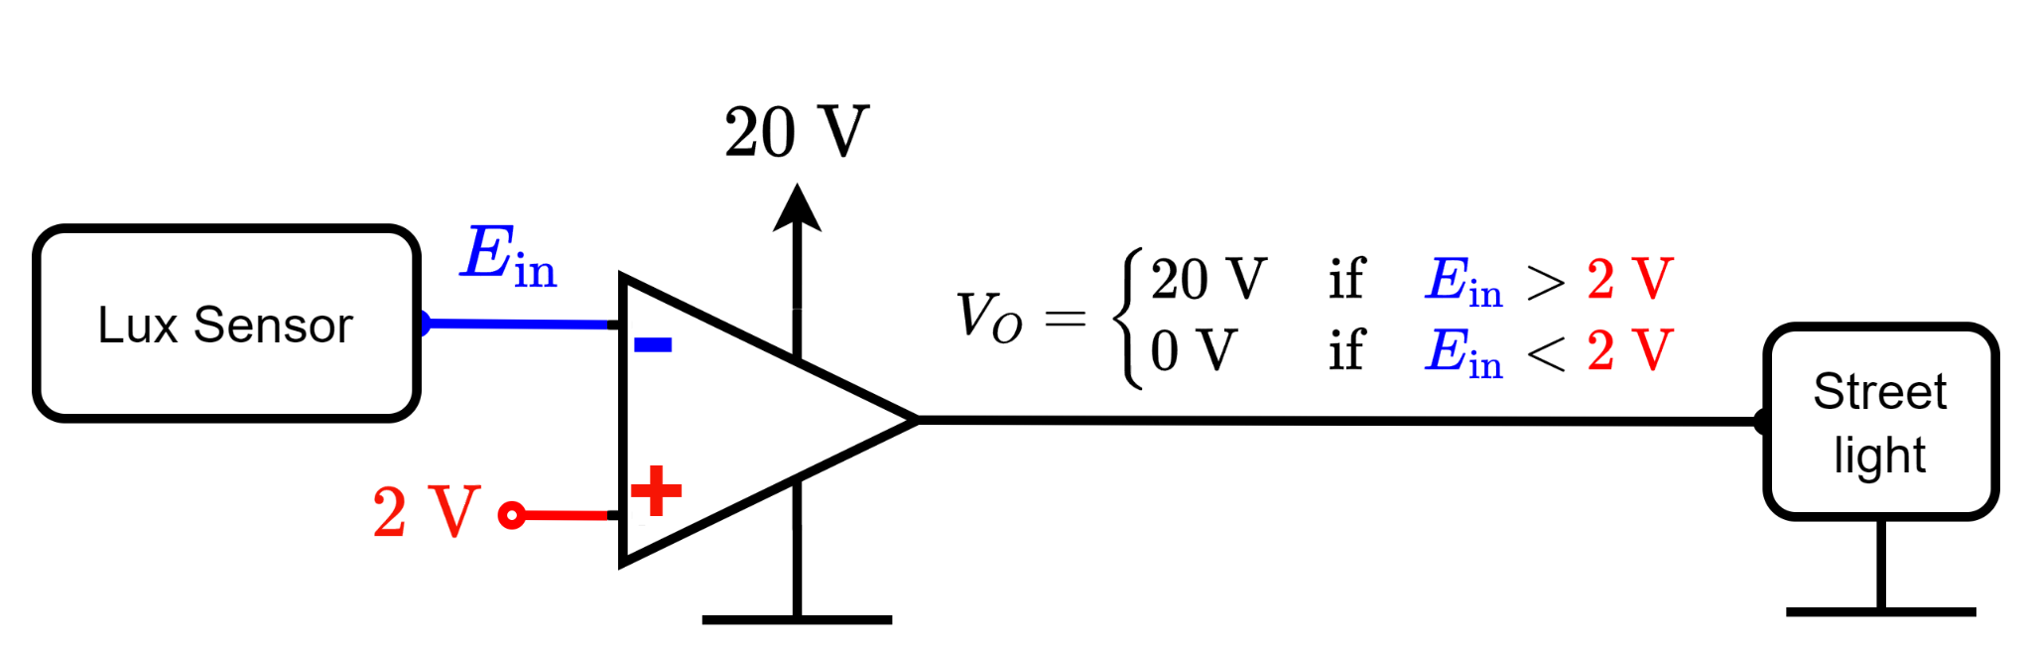

### 10. **Deduce** the expression for output, **Vo** from the circuit above

### 11. Design a circuit using op-amps to implement y=7x by an

1. Inverting amplifier
2. Non-inverting amplifier

### 12.

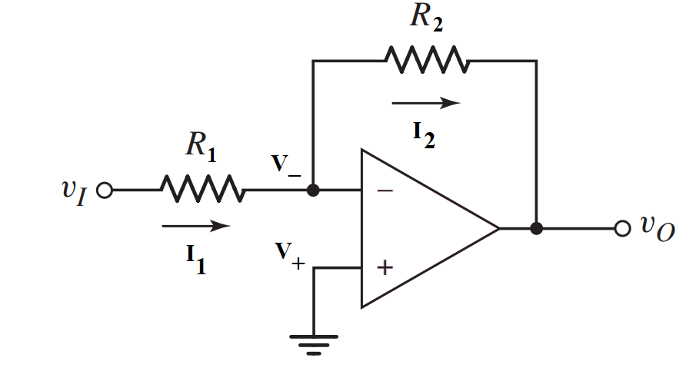

1. **Design** an inverting amplifier (i.e., find the values of R1 and R2 of the circuit shown in the Figure above) in such a way that the voltage gain is **−5**.
2. Consider the circuit you drew in (a) again. Assume the input vi = 0.1 sinωt (V) has a maximum current rating of 5 μA. What design changes, if any, are required for this input, if the voltage gain remains the same?
3. **Draw** the input and output waveforms of the circuit you designed in (c).

* **Analyze** the following circuit and derive the expression for the output voltage (Vout) in terms of the inputs. If V1=1 V, V2 = 2V, and V3 = 1.5 V, and all the resistors have equal values, calculate Vout.

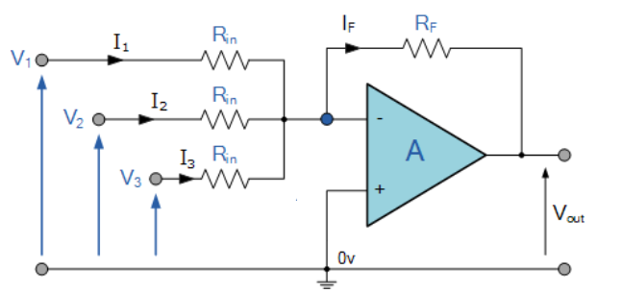

### 13. **Analyze** the following circuit to find an expression of f in terms of x, y, and z.

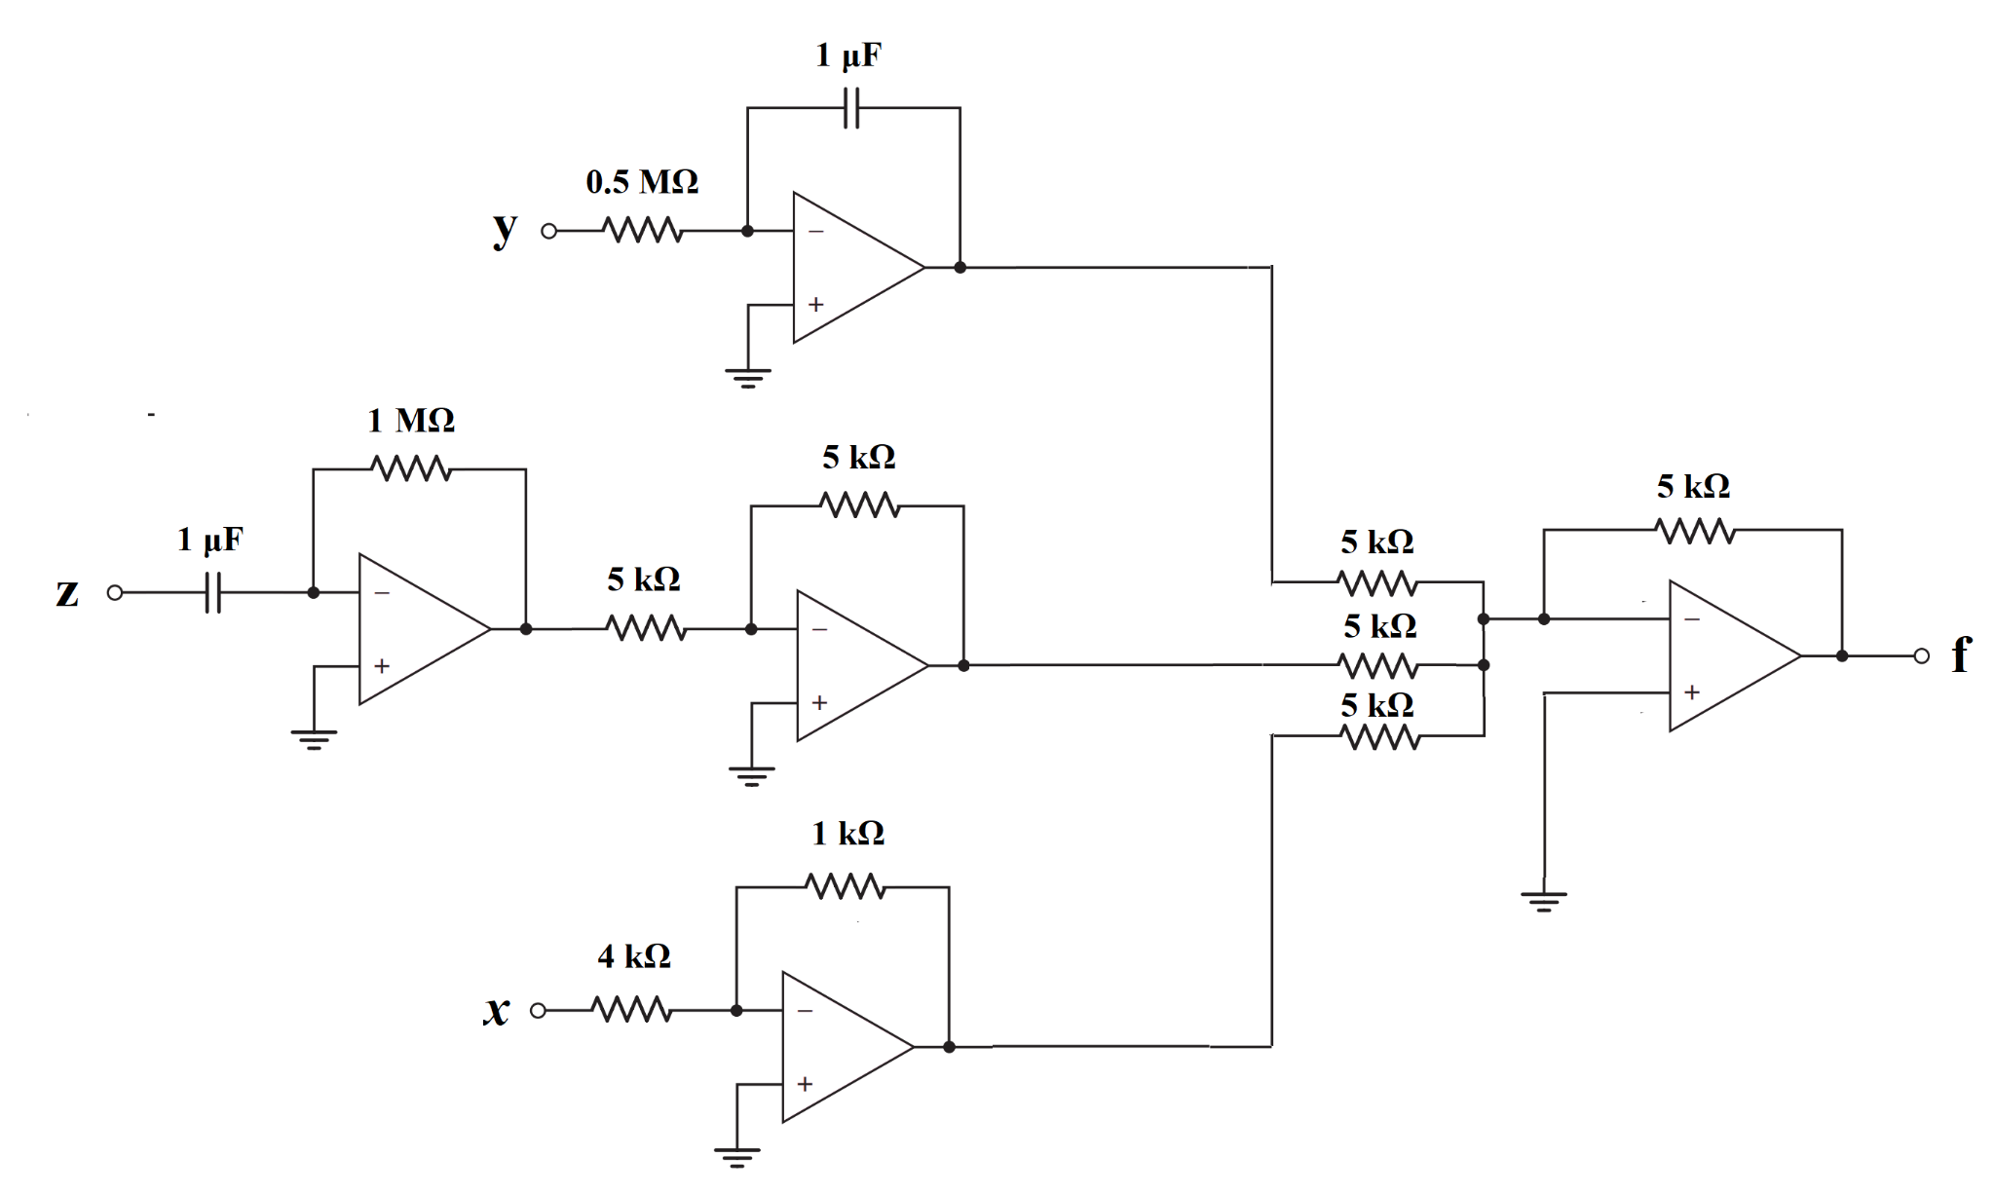

### 14. Consider the Ideal Op-Amp and find the value of Vo.

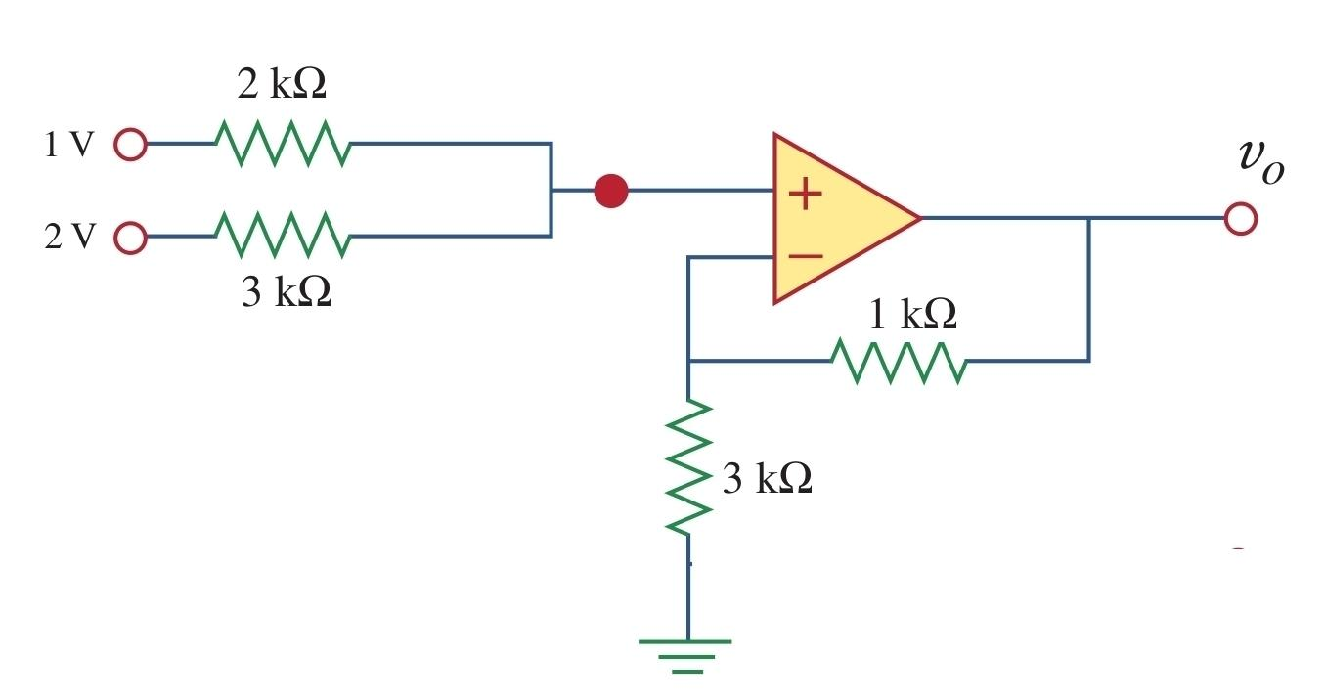

### 15.

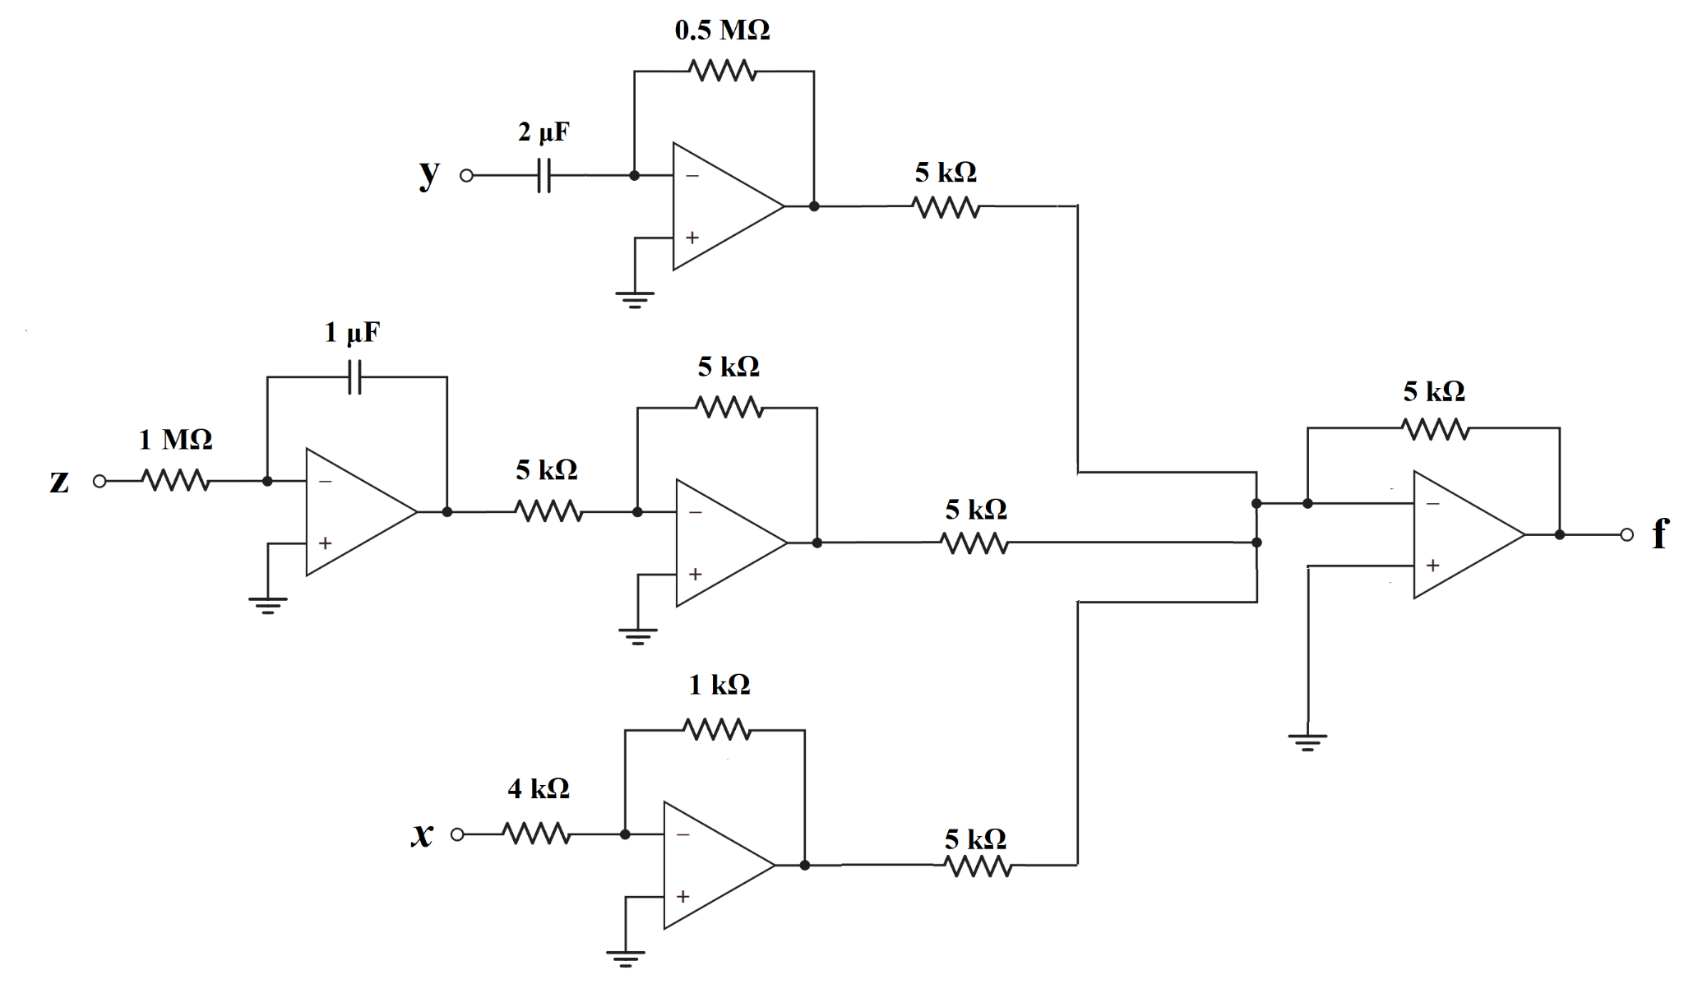

**Figure 3(a) Figure 3(b)**

1. **Analyze** the circuit in Fig 3(a) to find an expression of f in terms of x, y, and z. [4]
2. **Design** an inverting amplifier (i.e., find the values of R1 and R2 of the circuit shown in Fig. 3(b)) in such a way that the voltage gain is **−4**.  [3]
3. **Draw** the input and output waveforms of the circuit you designed in (b). [2]
4. Consider the circuit in Figure 3(b) again. Assume the inpurt vi = 0.1 sinωt (V) has a maximum current rating of 4 μA. What design changes, if any, is required for this input, if the voltage gain remains the same?

### 16.

**Design** an op-amp circuit to transform the sinusoidal voltage, ( is in units of **,** and time-period is ), to: 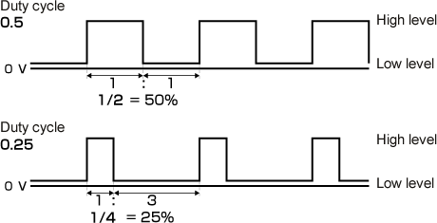

**[You must evaluate ]**

1. A square wave with a duty cycle of **50%**.
2. A square wave with a duty cycle of **25%**.

[**Duty Cycle:** Time of positive half cycle Time period]

For more information on duty cycle, click [here!](https://www.youtube.com/watch?v=u9M9REUmmDI)

[**Hint:** If is a sinusoidal function with period of then . So, for 25% duty cycle find the value of for which ]

# 

# **I-V**

### Identify which of these I-V curves are Linear and which are Nonlinear:

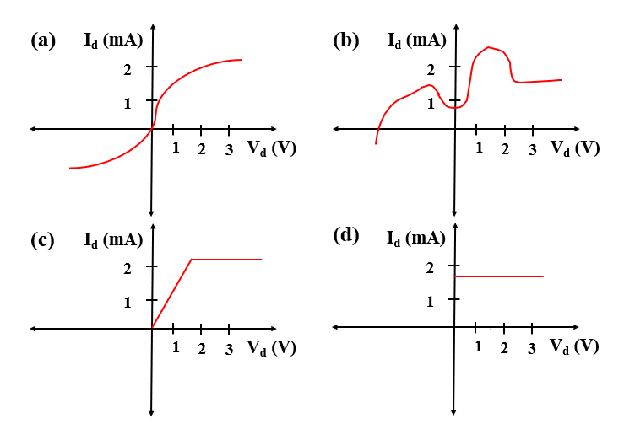

**Ans: Linear: (d)**

### Write down the slopes of these following regions in ascending order (you do not need to calculate the slopes)

1. 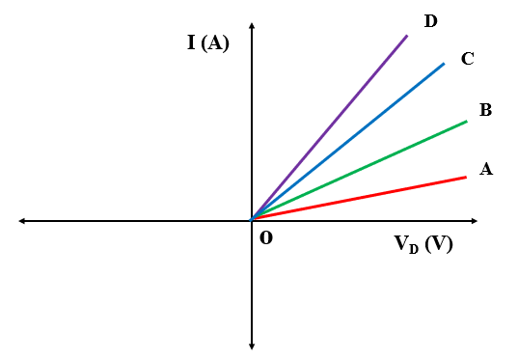(b) 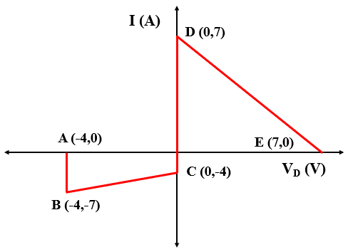

Ans: (a) |OA|<|OB|<|OC|<|OD|, (b) Slopes of AB and CD are equal(infinity). The DE slope is negative. However, the value of slope is higher than BC here. |BC|<|DE|<|AB|

### Find out the slope of the following curves



Answer: **Slope, |m|=**

|BC|= **=** =

|DE|= **=** =  **[Can you identify the issue in this curve? ]**

|AB|= **=** = **∞**

### Calculate and Show ‘C’ and ‘Io’ in the figures

**[Hint: use =c]**

### Draw the alternative circuit diagram, I-V curve and calculate the parameters with the following information:

i. Vo= 5V, m= 2 /

ii. Vo= 3.5 V, m= -2.5/

iii. Vo= -5V, m= 5/

**Solution:**

i. ||= i.e. , =

ii. ||= i.e. ,

iii. ||= i.e. ,

**Alternative Diagram:**

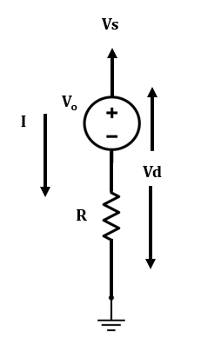

**I-V curve:**

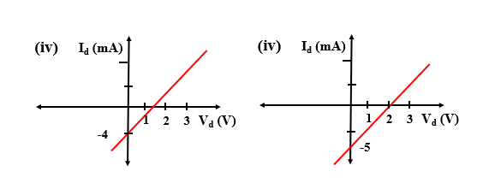

### Calculate and Show ‘C’ and ‘Vo’ in the figures

**[Hint: Use ]**

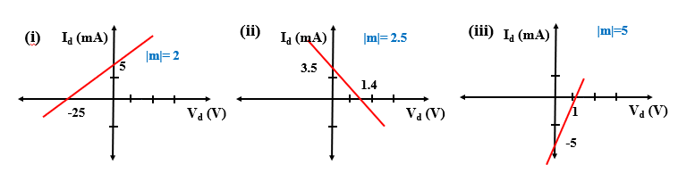

### Draw the alternative circuit diagram with the equivalent linear model, I-V curve and calculate the parameters with the following information:

i. Io= 5 mA, m= 2

ii. Io= 3.5 mA, m= -2.5 /

iii. Io= -5 mA, m= 5 /

**Solution:**

i. ||= i.e. , = ,

ii. ||= i.e. , ; as m is negative

iii. ||= i.e. ,

**Alternative diagram:**

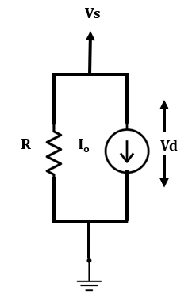

**I-V:** 

### From the I-V curve-

i. State the device model for each region,

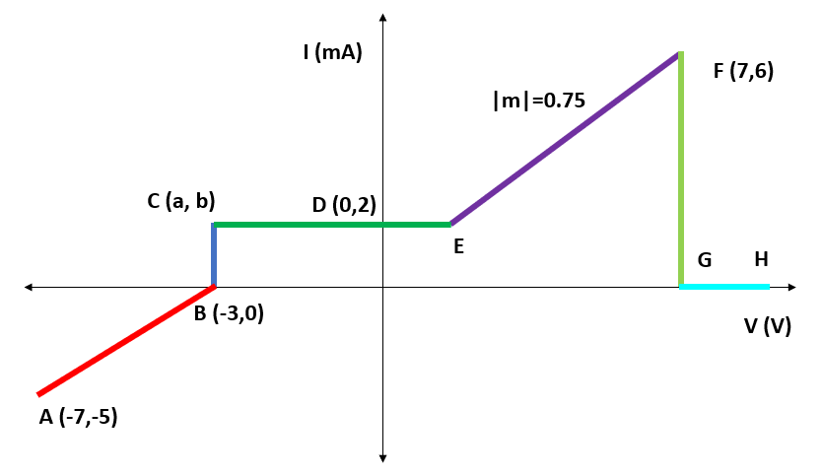

**Solution:**

**i.**

AB: Voltage source in series with a resistor/ Current source in parallel with a resistor

BC: Voltage source

CD: Current source

EF: Voltage source in series with a resistor/ Current source in parallel with a resistor

FG: Voltage source

### A Voltage Source, Vo= 10 V in series with a resistor of R= 3 .

i. Write down the equation representing this curve

ii. Determine the unknown parameters

iii. Label the I-V curve

**Solution:**

i. y= mx+c

Or, I= m. Vs

ii. Vo= 10 V, R=3

**|m|**

Y axis intersection: c= = mA

X axis intersection: = 10 V

iii.

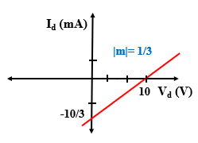

### A Voltage Source, Vo= -10 V in series with a resistor of R= 3 .

i. Write down the equation representing this curve

ii. Determine the unknown parameters

iii. Label the I-V curve

**Solution:**

i. y= mx+c

Or, I= m. Vs

ii. Vo= 10 V, R=3

**|m|**

Y axis intersection: c= = mA

X axis intersection: = -10 V

Iii.

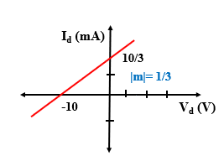

### A Current Source, Io= 5 mA in parallel with a resistor of R= 5 .

i. Write down the equation representing this curve

ii. Determine the unknown parameters

iii. Label the I-V curve

**Solution:**

i. y= mx+c

Or,

ii. Vo= 10 V, R=5

**|m|**

Y axis intersection : c= = 5 mA

X axis intersection:

Or, Vo= -5*5 V= -25V

iii.

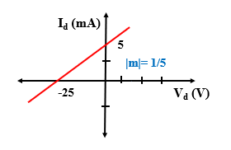

# 

# 

### You are provided with the following circuit elements:

• Two 1 kΩ resistors

• A 4 V voltage source

• A 2 V voltage source

Can you implement a circuit element X that has an IV characteristics, as seen in the right figure below, but by **ONLY USING THE ELEMENTS MENTIONED ABOVE**? The voltage polarity and current direction should be as shown in the left figure.

# 

# 

# **Diode Logic Gates**

### Assuming x, y, z are boolean variables, analyze the circuits below to find an expression of *“f”* in terms of x, y, and z.

#### i.

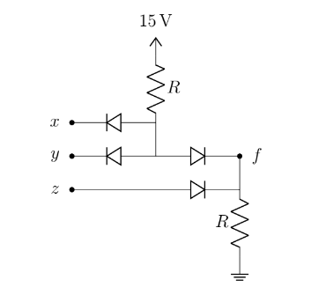

#### ii.

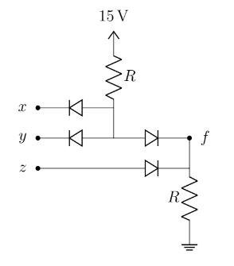

#### iii.

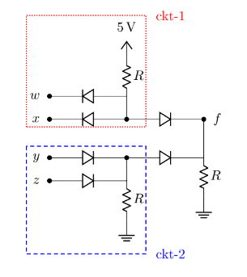

#### iv.

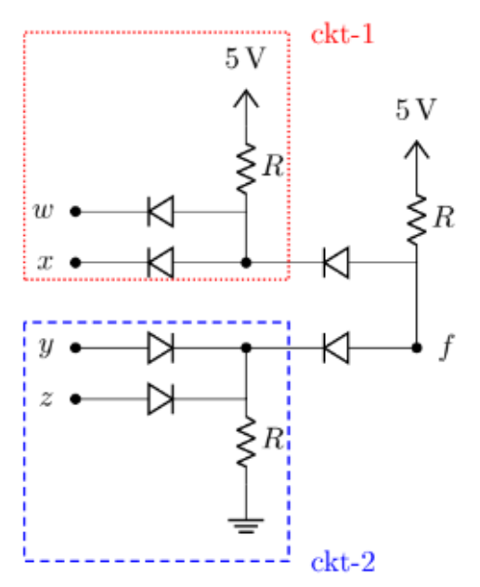

### Implement the following expressions using ideal diodes:

#### i. xy+ yz

#### ii. XOR

#### iii. XNOR

#### iv. (A+B)XY

### Design a 4 input AND gate using ideal diodes

### Design a 3 input OR gate using ideal diodes

### There will be 5 questions from 5 different topics in your exam and you will have to answer 4 out of these . You will need to fulfill the following conditions-

i. You **must** answer 3 questions from topic “A”, “B” and “C”

ii. You can answer one question from **either** “D” or “E”

Deduce the logic function using boolean variables A,B,C,D and E to implement your algorithm for choosing the questions.

### For this question, assume all the diodes are ideal.

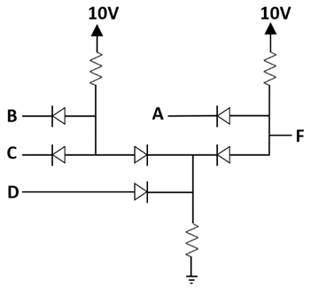

Figure 1

1. Assuming A, B, C, D are boolean variables, analyze the circuit of Figure 1 to find an expression of F in terms of A, B, C and D.
2. Analyze the circuit in Figure 1 to find the output voltage(s) F and complete the table in Figure 2, assuming A, B, C and D are voltage signals

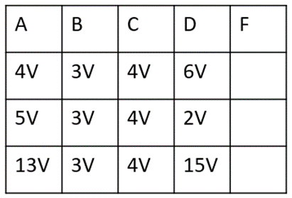

Figure 2

(c) Design a circuit using ideal diodes to implement the logic function

f = (x+y)z

### Maisha is designing a game where she needs to determine an algorithm for level upgrades. The quests in level-1 are expressed using Boolean variables A, B, C, D, and E. For upgrading from level-1 to level-2 she will need to fulfill the following conditions-

i. Quest “A” and “B” must be completed

ii. At Least one quest has to be completed from “C”, “D” and “E”

(a) **Deduce** the logic function, F, using Boolean variables A, B, C, D, and E to implement Maisha’s algorithm. [3]

(b) **Determine** the values of “F” in the following table using the logic function from (a). [2]

| A | B | C | D | E | F |
| --- | --- | --- | --- | --- | --- |
| 0 | 0 | 1 | 0 | 1 | ? |
| 0 | 1 | 1 | 1 | 0 | ? |
| 1 | 0 | 0 | 0 | 0 | ? |
| 1 | 1 | 1 | 0 | 0 | ? |

(c) **Draw** the circuit diagram implementing the logic function from (a). [3]

(d) **Discuss** whether you can design a NAND gate with Si diodes. [2]

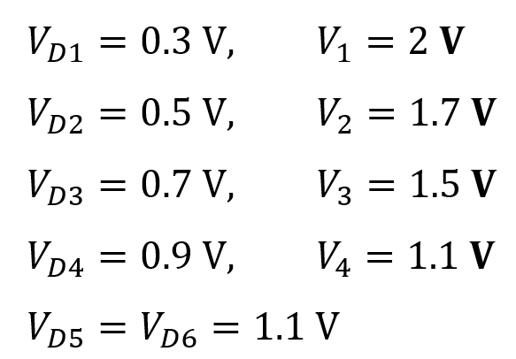

1. Find and . [5]
2. Find . [5]
3. **[BONUS – 5 Marks]:** Solve the circuit to get when and all other parameters remain the same.

### Solution:

**Bonus:**

When and , and are both in reverse bias as both and are greater than the supply voltage. So, between and (which is still , as obtained from previous answer), the higher voltage will propagate to . But, we still don’t know what is.

So, here is what we will do. We will assume for now that  **is higher than** . As, both diodes will not simultaneously be forward biased, is assumed to be forward biased. So the circuit becomes:

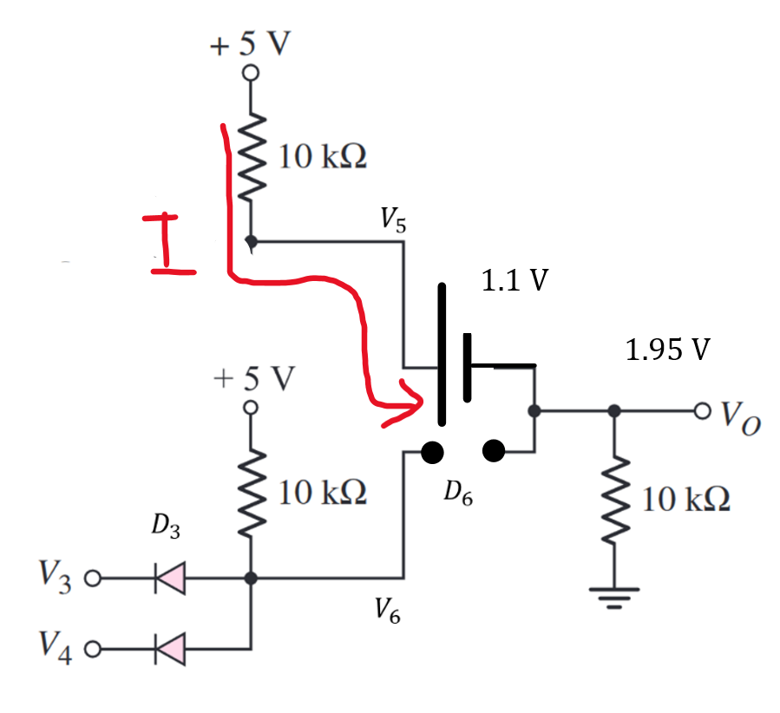

From the above circuit, and .

**Here, . So, our assumption that is higher than is true. So, the result is:**

**(Answer)**

# 

# **Diode: Method of assumed states**

*For the following circuits (a) Analyze the following circuit to find the values of ,,, and . Here, use the Method of Assumed State using the CVD model of diode with = 0.3 V. (b) Validate your assumptions about the states of the diodes.*

### 1.

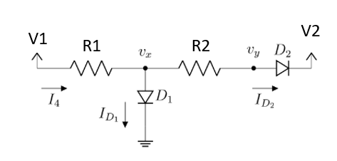

i. V1= 10 V, V2= -10 V, R1= 10 K, R2= 20K

ii. V1= -5 V, V2= 20 V, R1= 10 K, R2= 20K

### 2.

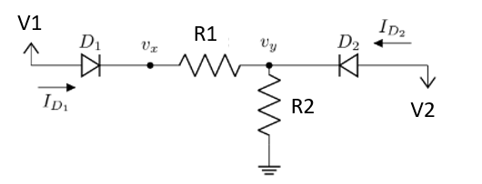

i. V1= 5 V, V2= -3.5 V, R1= 1 K, R2= 10K

ii. V1= 5 V, V2= -3.5 V, R1= 10 K, R2= 10K

### 3.

### 4.

# 

**Analyze** the circuit given above. **Calculate** the values of **I1, I2, I3**. You must **validate** your assumptions. Use the Constant-Voltage Drop model(CVD Model) with **VD0 = 0.8 V**.

### 5.

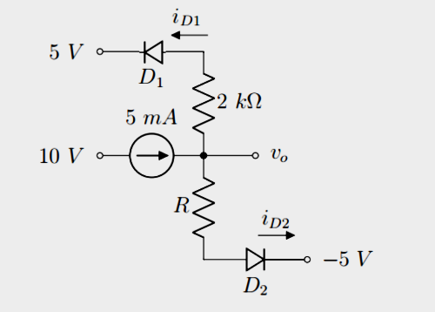

Find **Vo, iD1 and iD2** for R = 1 kΩ. Assume diode constant voltage drop model with Vdo = 0.7v . In each case, write down the states of the diodes (ON/OFF). You must verify your assumptions.

### 6.

# 

**Analyze** the following circuit. **Calculate** the values of VA, V0, ID1, and ID2. You must validate your assumptions. Use the Constant-Voltage Drop model with a cut in voltage of 0.6V [VD0 = 0.6 V]. *[Hints: You may start with calculating the voltage values first]*

* **Please find some other examples here**: [Week 4 (Method of Assumed State Examples).pdf](https://drive.google.com/file/d/1uMgvK4Vo4m_nfjzFVLr0OCmozDfUcihe/view?usp=share_link)

# 

# **Rectifiers**

### 1.

The input of a full-wave rectifier is a cosine voltage with peak = 5 V and frequency 60 Hz, and output load resistance is R = 2 kΩ. Silicon diodes are used in this circuit for which the forward drop is = 0.7 V.

(a) Briefly explain the purpose of a rectifier and describe its operation.

(b) Show the input and output waveforms.

(c) Calculate the DC value of the output voltage.

Now after connecting a capacitor in parallel with the load, the output becomes a ripple voltage **Vout = ±0.2 V**

(d) Calculate the **peak-to-peak ripple voltage**, and from that, the value of the capacitor.

(e) Calculate the average of the output voltage after connecting the capacitor. Compare this with the DC value determined in ‘c’ and comment on the difference between these two.

### 2.

The input of a **Half-wave rectifie**r is a sine voltage with peak VM = 10 V and frequency 55 Hz, and output load resistance is R = 2.5 kΩ. Silicon diodes are used in this circuit for which the forward drop is = 0.4 V.

(a) Calculate the DC value of the output voltage.

Now after connecting a capacitor in parallel with the load, the output becomes a ripple voltage **Vout = ±0 V.**

(d) Calculate the **peak-to-peak ripple voltage**, and from that, the value of the capacitor.

(e) Calculate the average of the output voltage after connecting the capacitor. Compare this with the DC value determined in ‘c’ and comment on the difference between these two.

(f) Draw the **Voltage Transfer Characteristic (VTC) curve**

### 3.

The input of a full-wave rectifier is expressed by, Vs(t)= 7sin(400πt), and output load resistance is R = 5 kΩ. Silicon diodes are used in this circuit for which the forward drop is = 0.3 V.

(a) Calculate the input and output wave frequency.

(b) Show the input and output waveforms.

(c) Calculate the DC value of the output voltage.

Now after connecting a capacitor, C= 100 µF in parallel with the load.

(d) Calculate the peak-to-peak ripple voltage,

(e) Calculate the average of the output voltage after connecting the capacitor. Compare this with the DC value determined in ‘c’ and comment on the difference between these two.

(f) How can you provide better filtering for the output waves?

(g) What is the frequency of the Ripple voltage?

### 4.

The input of a **Half-wave rectifier** is a **Square** wave voltage with peak = 15 V and frequency 0.5 Hz, and output load resistance is R = 5 kΩ. Silicon diodes are used in this circuit for which the forward drop is = 0.7 V.

i. Show the input and output waveforms.

ii. Draw the VTC curve

### 5.

The input of a **full-wave rectifier** is a **Square** wave voltage with peak = 15 V and frequency 0.5 Hz, and output load resistance is R = 5 kΩ. Silicon diodes are used in this circuit for which the forward drop is = 0.7 V.

i. Show the input and output waveforms.

ii. Draw the VTC curve

### 6.

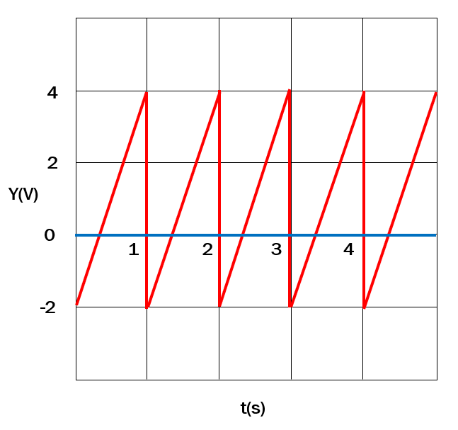

The input of a Half-wave rectifier is exhibited in the Figure above and output load resistance is R = 5 kΩ. Silicon diodes are used in this circuit for which the forward drop is = 0.7 V.

i. Show the input and output waveforms.

ii. Draw the VTC curve

### 7.

A full-wave rectifier is designed to deliver a maximum current IL = 120 mA to the load. The rectifier produces an output with a ripple of 5% of the peak output voltage. An input line voltage of 120 V (peak), 50 Hz is available. A 10:1 step-down transformer is used to transform the supply voltage to 12 V (peak).

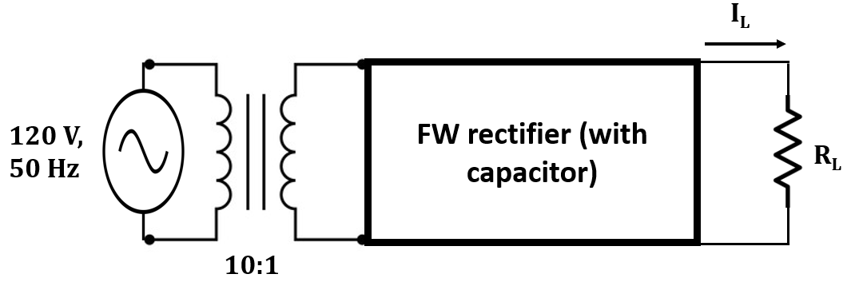

1. Draw the Voltage Transfer Characteristics of the full-wave rectifier. [2]
2. Calculate the peak output voltage. [1]
3. Determine the value of the Load Resistor to deliver a maximum load current of 120mA. [2]
4. Deduce the value of the Capacitor and the DC average value. [1]
5. Assume the transformer is removed and the rectifier is directly connected to the AC power supply line. Discuss the state of the diodes. [ Hint: use the Peak Input Value of the rectifier input] [3]

# 

# **Hybrid Problems**

### 1.

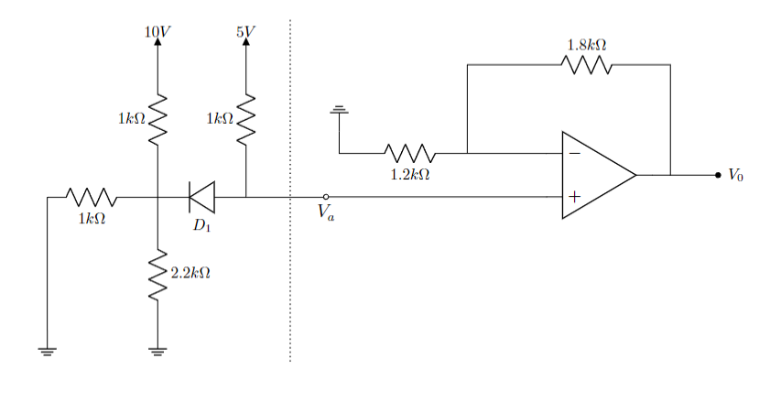

The saturation voltages of the Op-Amp are given as- and . The forward voltage drop of the diode, is .

(a) **Determine** the operating mode diode, . Verify your assumption with necessary calculations.

(b) **Calculate** the voltage at - (i) node ‘Va’, (ii) non-inverting terminal of the Op-Amp, (iii) inverting terminal of the Op-Amp.

(c) Find out the output voltage, Vo of the Op-Amp.

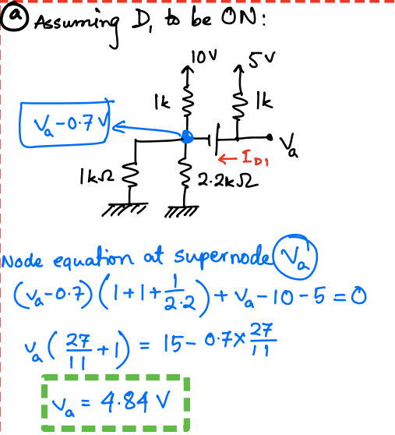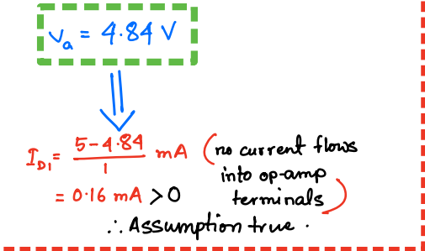

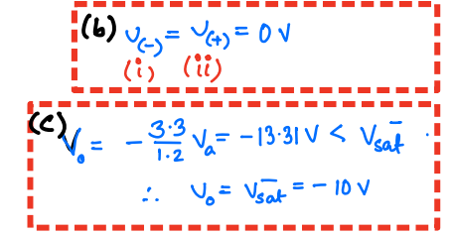



### 2.

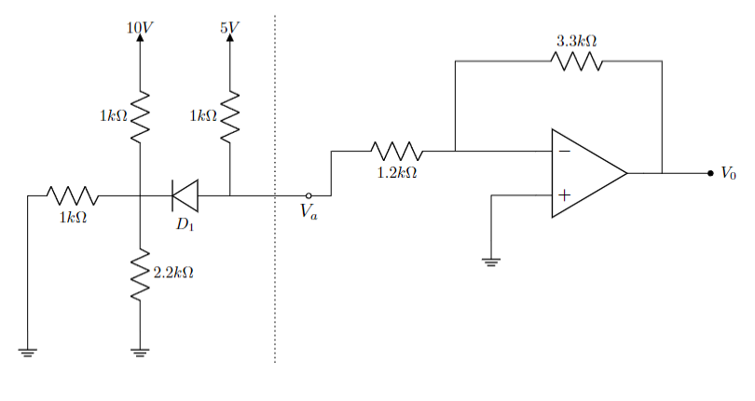

The saturation voltages of the Op-Amp are given as- and . The forward voltage drop of the diode, is .

(a) **Determine** the operating mode diode, . Verify your assumption with necessary calculations.

(b) **Calculate** the voltage at - (i) node ‘Va’, (ii) non-inverting terminal of the Op-Amp, (iii) inverting terminal of the Op-Amp.

(c) Find out the output voltage, Vo of the Op-Amp.

### 3.

You are provided with the diagram below as a starting point for designing an AC to DC converter. Input voltage source is an sinusoidal voltage source (), with 2V peak to peak voltage (i.e. 1 V amplitude) and the DC voltage is around 10 V (with ripple) at the output terminals ().

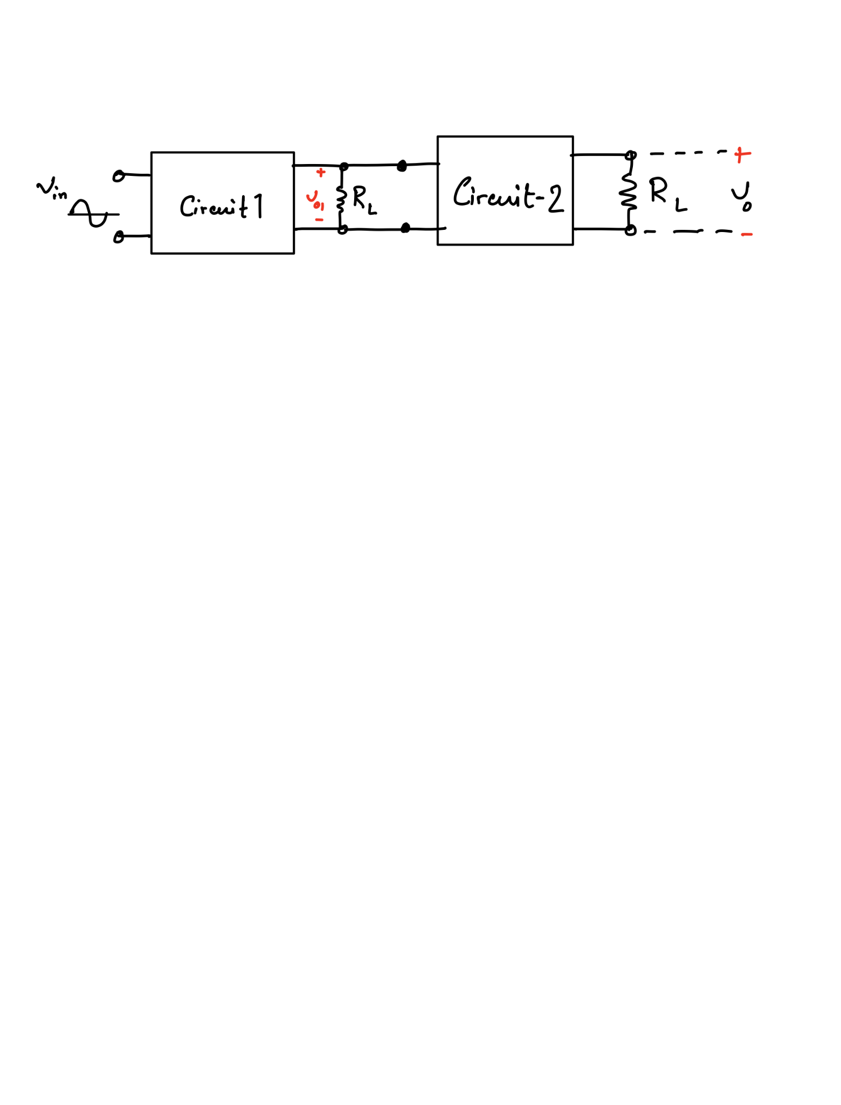  
So, in order to solve this problem, you are provided with a single diode (with V), two resistors ( and , excluding the load resistors ) and an UA741 op-amp.

1. Design **circuit-1** with the single diode and (is already provided in the diagram as output terminals of **circuit-1**) to get a rectified voltage and determine the DC value of the output voltage () of the circuit. [1+2]
2. Determine the ripple voltage of . [Ripple voltage is defined as the difference between the maximum and minimum value of a DC voltage.] [2]
3. What should be the value of a capacitor used at the output end of **circuit-1** with to reduce the ripple voltage of to . How should the capacitor be connected with in the diagram? [4+1]
4. Design an amplifier using an operational amplifier as **circuit-2** to increase the DC voltage level of the output voltage of the circuit designed in (c) to 10 V. Find the ripple voltage of the amplified voltage signal. [4+1]

# **Rectifiers**

1. The input of a full-wave rectifier is a cosine voltage with peak = 5 V and frequency 60 Hz, and output load resistance is R = 2 kΩ. Silicon diodes are used in this circuit for which the forward drop is = 0.7 V.

(a) Briefly explain the purpose of a rectifier and describe its operation. [1]

(b) Show the input and output waveforms. [2]

(c) Calculate the DC value of the output voltage. [1]

Now after connecting a capacitor in parallel with the load, the output becomes a ripple voltage **Vout = ±0.2 V**

(d) Calculate the **peak-to-peak ripple voltage**, and from that, the value of the capacitor. [2]

(e) Calculate the average of the output voltage after connecting the capacitor. Compare this with the DC value determined in ‘c’ and comment on the difference between these two. [2]

1. The input of a **Half-wave rectifie**r is a sine voltage with peak VM = 10 V and frequency 55 Hz, and output load resistance is R = 2.5 kΩ. Silicon diodes are used in this circuit for which the forward drop is = 0.4 V.

(a) Calculate the DC value of the output voltage. [1]

Now after connecting a capacitor in parallel with the load, the output becomes a ripple voltage **Vout = ±0.3 V.**

(b) Calculate the **peak-to-peak ripple voltage**, and from that, the value of the capacitor. [2]

(c) Draw the **Voltage Transfer Characteristic (VTC) curve [2]**

1. The input of a full-wave rectifier is expressed by, Vs(t)= 7sin(400πt), and output load resistance is R = 5 kΩ. Silicon diodes are used in this circuit for which the forward drop is = 0.3 V.

(a) Calculate the input and output wave frequency. [2]

(b) Show the input and output waveforms.

Now after connecting a capacitor, C= 100 µF in parallel with the load.

(c) Calculate the peak-to-peak ripple voltage,

(d) How can you provide better filtering for the output waves?

(e) What is the frequency of the Ripple voltage?

1. The input of a **Half-wave rectifier** is a **Square** wave voltage with peak = 15 V and frequency 0.5 Hz, and output load resistance is R = 5 kΩ. Silicon diodes are used in this circuit for which the forward drop is = 0.7 V.

i. Show the input and output waveforms. [4]

ii. Draw the VTC curve [2]

1. The input of a **full-wave rectifier** is a **Square** wave voltage with peak = 15 V and frequency 0.5 Hz, and output load resistance is R = 5 kΩ. Silicon diodes are used in this circuit for which the forward drop is = 0.7 V.

i. Show the input and output waveforms. [4]

ii. Draw the VTC curve [2]

1. 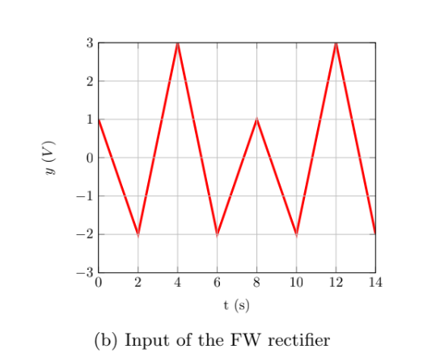

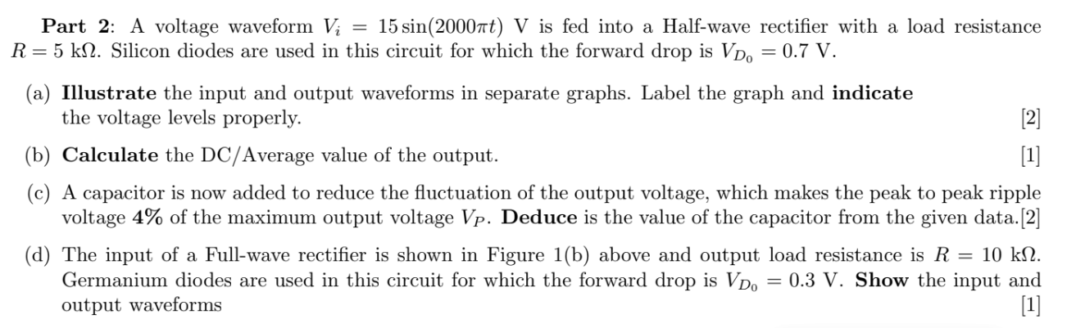



The input of a **Half-wave rectifier** is exhibited in the Figure above and output load resistance is R = 5 kΩ. Silicon diodes are used in this circuit for which the forward drop is = 0.7 V.

i. Show the input and output waveforms. [3]

ii. Draw the VTC curve [2]

Iii. Calculate input and output frequency [3]



1. The input of a **full-wave rectifier** is exhibited in the Figure above and output load resistance is R = 5 kΩ. Silicon diodes are used in this circuit for which the forward drop is = 0.7 V.

i. Show the input and output waveforms. [3]

ii. Draw the VTC curve [2]

Iii. Calculate input and output frequency [3]

1. A full-wave rectifier is designed to deliver a maximum current IL = 120 mA to the load. The rectifier produces an output with a ripple of 5% of the peak output voltage. An input line voltage of 120 V (peak), 50 Hz is available. A 10:1 step-down transformer is used to transform the supply voltage to 12 V (peak).



1. **Draw** the Voltage Transfer Characteristics of the full-wave rectifier. [2]
2. **Calculate** the peak output voltage. [1]
3. **Determine** the value of the Load Resistor to deliver a maximum load current of 120mA. [2]
4. **Deduce** the value of the Capacitor and the DC average value. [1]
5. Assume the transformer is removed and the rectifier is directly connected to the AC power supply line. **Discuss** the state of the diodes. [ Hint: use the Peak Input Value of the rectifier input] [3]

# **BJT**

**Q4**

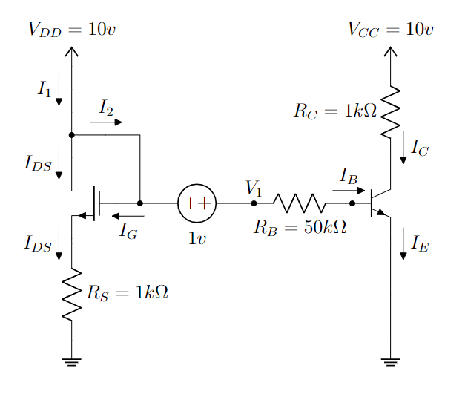

In the circuit above, the MOSFET and BJT have the following parameters,

**K = 4 mA/V2, VT = 0.9 v, 𝜷 = 100, VBE(active) = 0.7 v, VBE(sat) = 0.8 v**

1. **Find out the gate voltage of the MOSFET.**
2. **Calculate V1.**
3. **Find out the expression for VGS,VDS and VOV.**
4. **Find** the operating mode of the MOSFET using the expressions from ©. [Hint: You don’t need any assumption]
5. **Calculate** IDS and VDS using the given parameters.
6. Assume that the BJT is in the saturation mode. Now, **calculate** IB, IC, IE. You must **validate** the given assumption.

# 

# **MOSFET**

**Q1.**

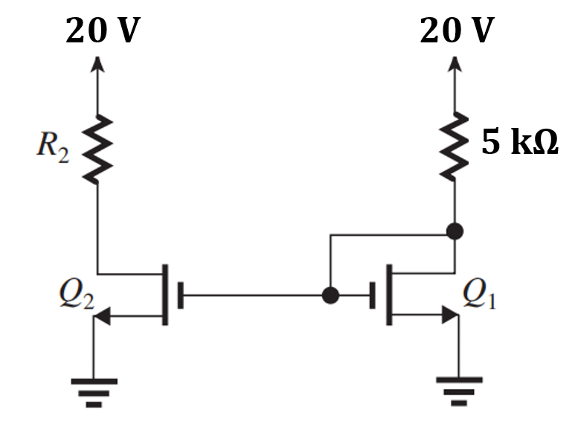

In the circuit above, the MOSFETs have the following parameters, k’n=2 mA/V2, W/L= 2.5, VT=0.5 V.

(a) **Find out** the operating mode of Q1 [Hint: For Triode mode Vds<Vov and for Saturation Vds>= Vov]

(b) **Determine** the value of R2 that results in Q2 operating at the edge of the saturation region.

(c ) **Calculate the on-state resistance,** Ron for Q2.

(d) An inverter is designed using Q2 and a 10K resistor. **Draw** the VTC graph for the inverter.

**Q2.**

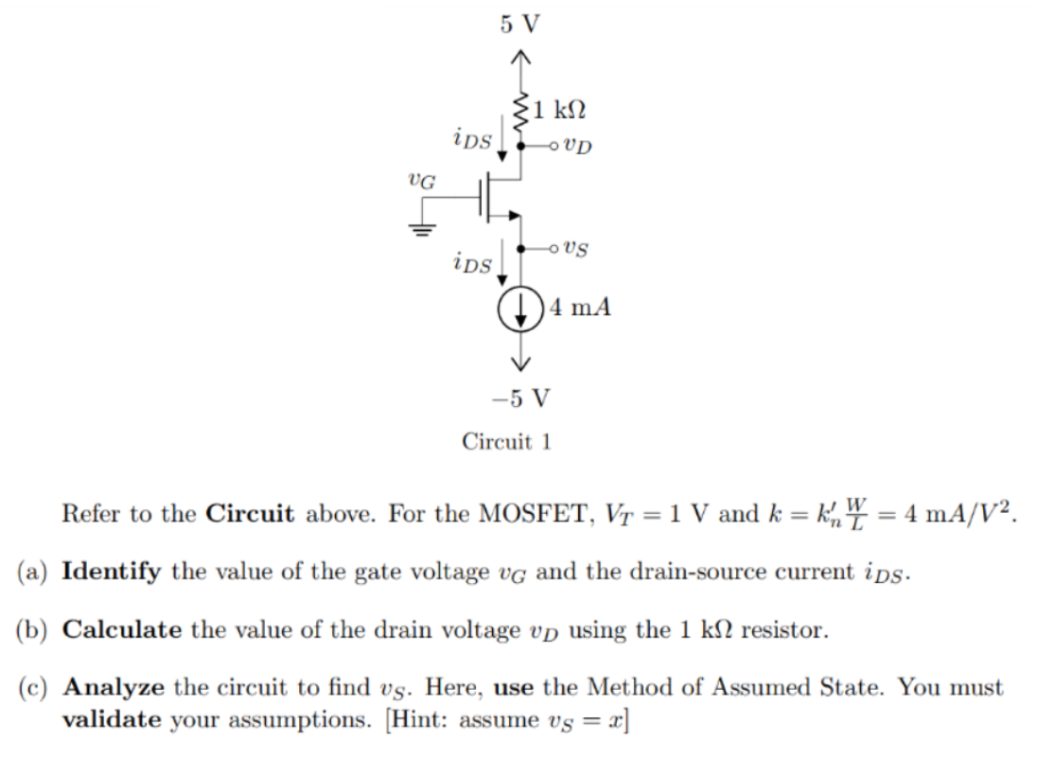

**Q3**

For the following circuit, find **f** in terms of boolean input **A, B, C, D**.

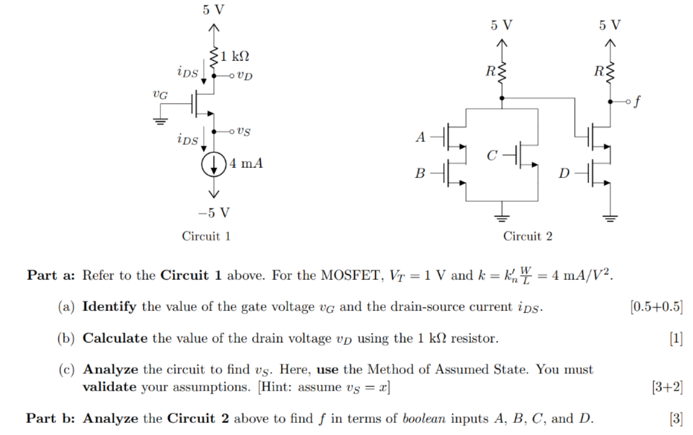

**Q4**

Use MOSFET to implement the Boolean Logic function, **F =**

**Q5**

Draw the VTC of a NOR gate using MOSFET S-model.

**Q6**

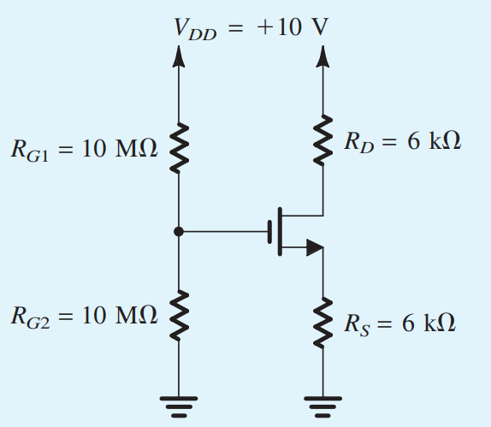

Analyze the circuit to find iD and vD using Method of Assumed State. You must validate your assumptions.

Here, VT = 1v, k = 5 mA/v2

**Q7**Implement using MOSFETs:

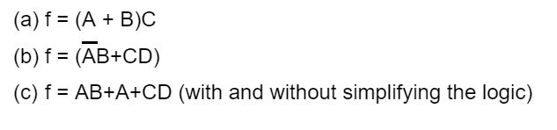

**Q8**

